Practical 5
1. Aim
To study and configure virtual networking in VMware Workstation and Oracle VirtualBox, and to understand and test different virtual network modes such as NAT, Bridged Networking, Host-Only Networking, and Internal Networking.
2. Requirements
Hardware Requirements
- A computer/laptop with sufficient RAM and storage.
- Active network connection for testing Internet connectivity.
- Hardware virtualization support enabled in BIOS/UEFI, if required.
Software Requirements
- VMware Workstation
- Oracle VirtualBox
- A virtual machine with an operating system such as Windows or Linux.
- Appropriate guest operating system network drivers/tools.
3. Introduction to Virtual Networking
Virtual networking allows virtual machines (VMs) to communicate with:
- The host computer
- Other virtual machines
- The local physical network
- The Internet
A virtual machine does not normally connect directly to the physical network hardware. Instead, the virtualization software provides a virtual network adapter to the VM and connects it to a virtual networking system.

4. Important Virtual Networking Components
4.1 Virtual Network Adapter
A virtual network adapter is a software-based network interface assigned to a virtual machine.
The guest operating system sees it similarly to a physical Ethernet adapter.
For example, a Linux VM may show an interface such as:
ens33
or
eth0
depending on the operating system and configuration.
4.2 Virtual Switch
A virtual switch connects virtual machines and/or the host system to a particular virtual network.
It performs a function similar to a physical network switch, but it exists within the virtualization environment.
4.3 DHCP
DHCP (Dynamic Host Configuration Protocol) can automatically assign network configuration such as:
- IP address
- Subnet mask
- Default gateway
- DNS server
Both VMware and VirtualBox can provide DHCP services for certain virtual networks.
5. Common Virtual Networking Modes
Before configuring the networks, it is important to understand what each mode is used for.
Network Mode | Internet Access | Host ↔ VM | VM ↔ VM | External Network ↔ VM
NAT | Yes | Limited/indirect | Usually possible through same NAT network | Generally no direct access
Bridged | Yes | Yes | Yes | Yes
Host-Only | No* | Yes | Yes | No
Internal Network | No | No | Yes | No
* Host-Only can communicate with the Internet only if additional routing/NAT is configured.
5.1 NAT
NAT (Network Address Translation) allows the virtual machine to access external networks through the host computer's network connection.
The VM receives a private IP address from the virtualization software.
VM
│
│ Private IP
▼
Virtual NAT
│
▼
Host
│
▼
Internet
Main use
NAT is useful when the VM needs Internet access, but does not need to appear as an independent device on the physical network.
5.2 Bridged Networking
In Bridged Networking, the VM is connected to the same physical network as the host.
The VM behaves more like another physical computer connected to the same router/network.
Physical Router
/ \
/ \
Host VM
The VM normally obtains an IP address from the physical network's DHCP server.
Main use
Bridged networking is useful when the VM needs to communicate directly with other devices on the local network.
5.3 Host-Only Networking
Host-Only networking creates a private network between the host computer and virtual machines.
Host
│
Host-Only Network
/ \
VM 1 VM 2
The virtual machines can communicate with each other and the host, but they normally cannot access the Internet through this network.
Main use
Host-Only networking is useful for:
- Testing
- Development
- Network laboratories
- Isolated VM environments
5.4 Internal Network
An Internal Network creates a private network between virtual machines.
Internal Network
/ \
VM 1 VM 2
The host itself is not directly connected to this network.
Main use
It is useful when multiple VMs need to communicate with one another in an isolated environment.
6. Part A — Configure Virtual Networking in VMware Workstation
6.1 Open VMware Workstation
- Launch VMware Workstation.
- Select the virtual machine that you want to configure.
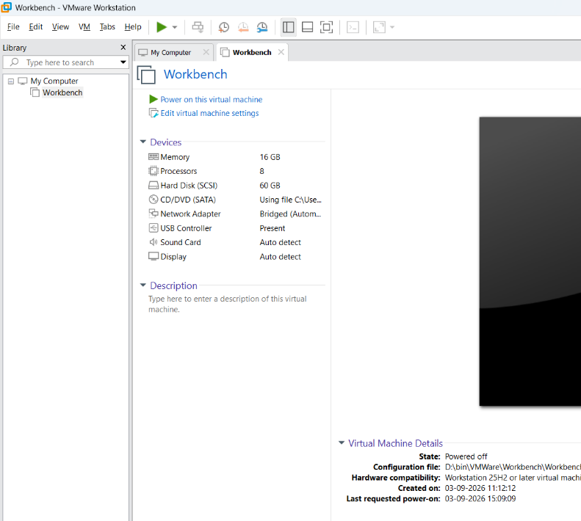
- Make sure the VM is powered off before changing important network adapter settings.
6.2 Open Virtual Machine Network Settings
- Select the required virtual machine.
- Click Edit virtual machine settings.
- Select Network Adapter.
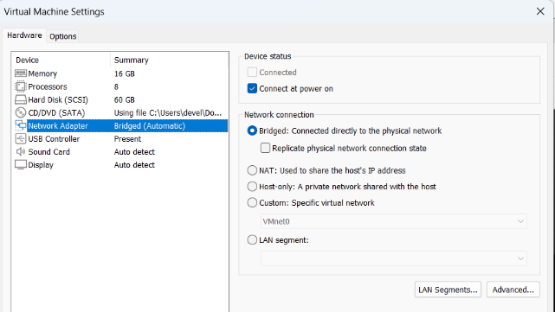
The available networking options will be displayed.
Typical options include:
- Bridged
- NAT
- Host-only
- Custom
7. Configure NAT in Vmware (VMnet8)
Steps
- Open the VM's Virtual Machine Settings.
- Select Network Adapter.
- Select NAT: Used to share the host's IP address.
- Ensure that Connected and Connect at power on are enabled.

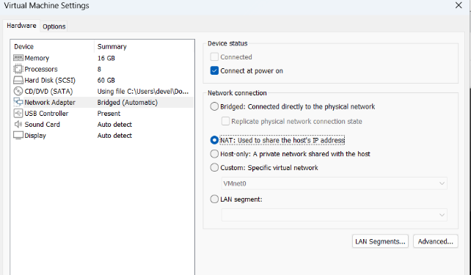
- Click OK.
- Start the virtual machine.
The VM should now receive an IP address from the VMware NAT network.
7.1 Check the IP Address
On Linux
Open the terminal and execute:
ip addr
or:
ip a
Look for the active network interface and its IPv4 address.
Example:
inet 192.168.xxx.xxx/24
On Windows
Open Command Prompt and execute:
ipconfig
The IPv4 address of the virtual network adapter will be displayed.
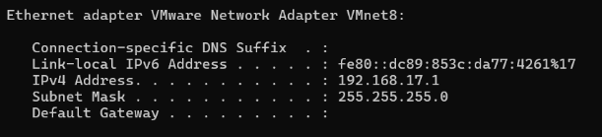
7.2 Test Internet Connectivity
From the VM, execute:
ping 8.8.8.8
If replies are received, the VM can reach the Internet through the NAT connection.
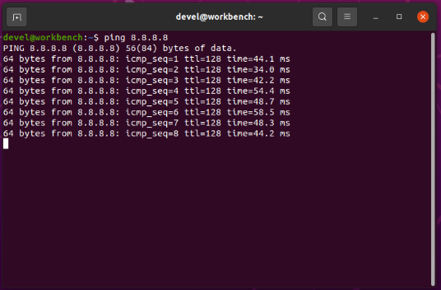
DNS can also be tested using:
ping google.com
If both work, network connectivity and DNS resolution are functioning.
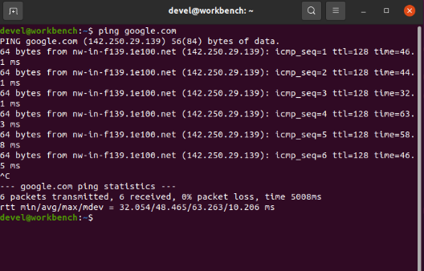
8. Configure Bridged Networking in Vmware (Vmnet0)
Steps
- Power off the VM.
- Open Virtual Machine Settings.
- Select Network Adapter.
- Select Bridged: Connected directly to the physical network.
- Enable Connected and Connect at power on.
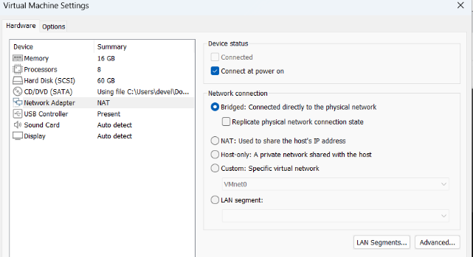
- Click OK.
- Start the VM.
The VM will now be connected to the physical network through the host's network adapter.
8.1 Check the IP Address
On Linux:
ip addr
On Windows:
ipconfig
The VM should normally receive an IP address from the same physical network's DHCP server.
For example:
Host: 192.168.1.10
VM: 192.168.1.20
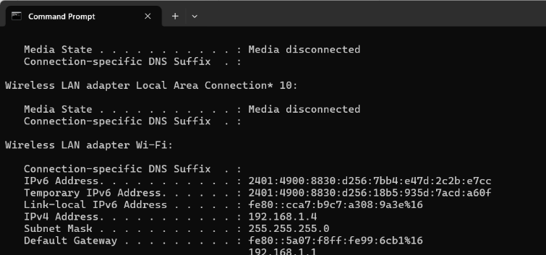
Both systems are therefore on the same network.
8.2 Test Connectivity
From the VM, test the gateway:
ping <gateway-ip>
For example:
ping 192.168.1.1
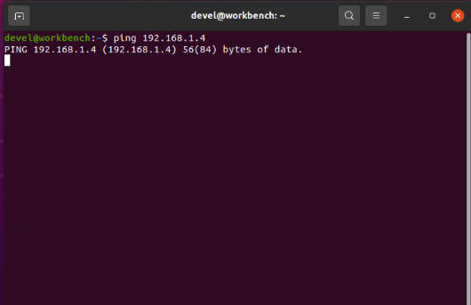
Internet connectivity can then be tested:
ping 8.8.8.8
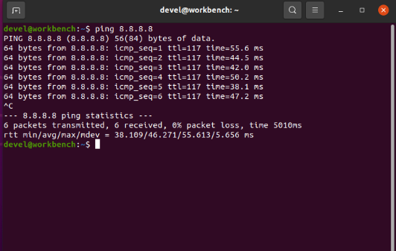
9. Configure Host-Only Networking in Vmware (Vmnet1)
Steps
- Power off the VM.
- Open Virtual Machine Settings.
- Select Network Adapter.
- Select Host-only.
- Enable Connected and Connect at power on.
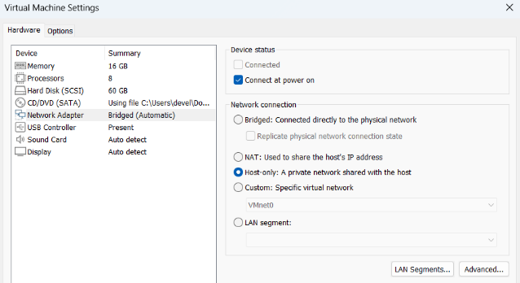
- Click OK.
- Start the VM.
The VM will now communicate through VMware's private Host-Only network.
9.1 Check Connectivity Between Host and VM
First find the VM's IP address:
ip addr
Suppose the VM receives:
192.168.56.10
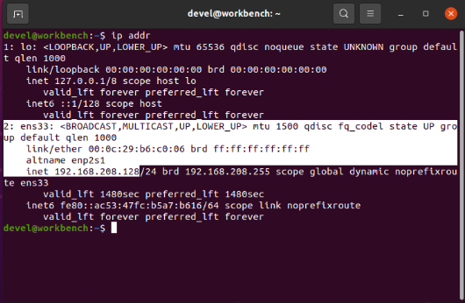
From the host computer, ping the VM:
ping 192.168.56.10
If replies are received, communication between the host and VM is working.
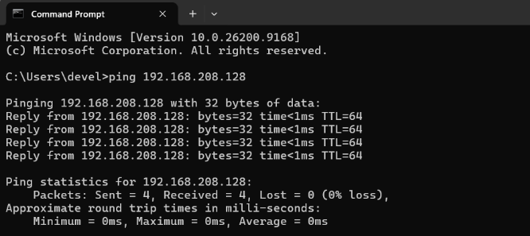
Similarly, the VM can ping the host's Host-Only adapter address.
10. Part B — Configure Virtual Networking in Oracle VirtualBox
Now we will perform the same concepts using Oracle VirtualBox.
11. Open VirtualBox Network Settings
- Start Oracle VirtualBox.
- Select the required virtual machine.
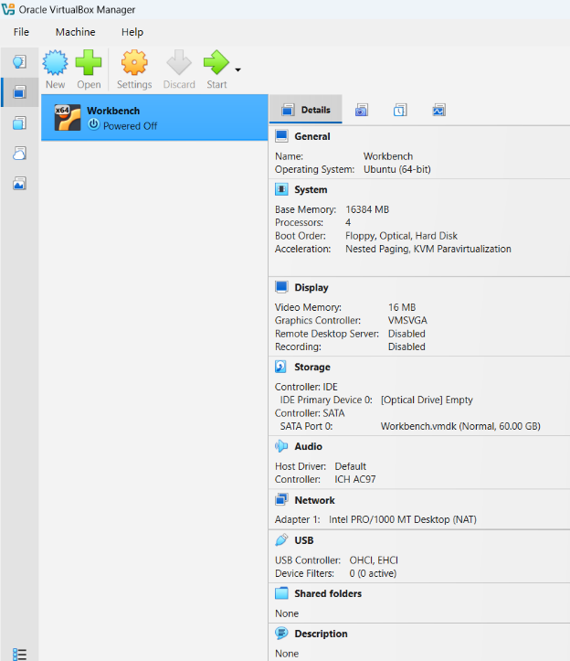
- Click Settings.
- Select Network.
- Select Adapter 1.
- Enable Enable Network Adapter.
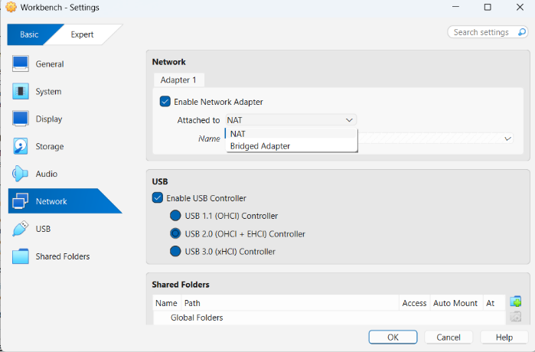
The Attached to dropdown contains the available networking modes.
Common options include:
- NAT
- Bridged Adapter
- Host-Only Adapter
- Internal Network
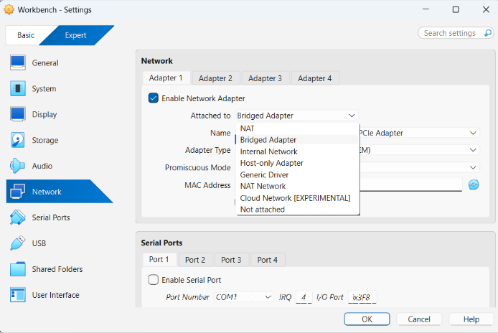
12. Configure NAT in VirtualBox
Steps
- Open the VM's Settings.
- Select Network → Adapter 1.
- Enable Enable Network Adapter.
- Set Attached to as:
NAT
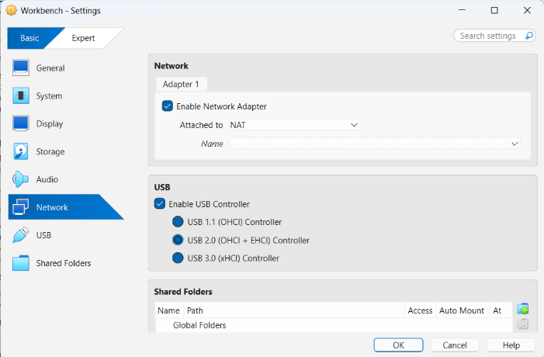
- Click OK.
- Start the VM.
VirtualBox will provide NAT connectivity to the VM.
2.1 Check Network Connectivity
Test Internet access:
ping 8.8.8.8
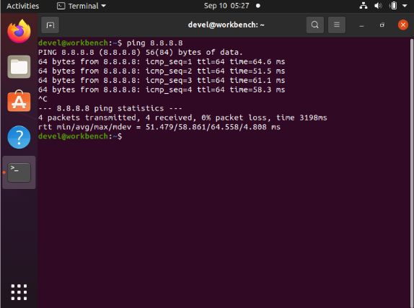
Then test DNS:
ping google.com
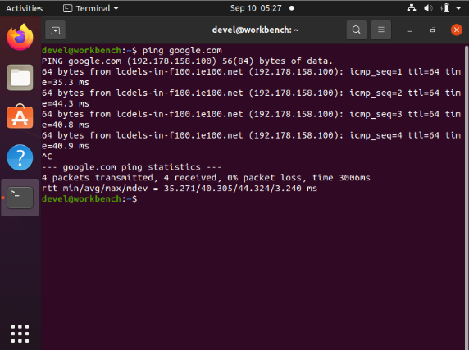
13. Configure Bridged Adapter in VirtualBox
Steps
- Power off the VM.
- Open:
Settings → Network → Adapter 1
- Enable the network adapter.
- Set Attached to as:
Bridged Adapter
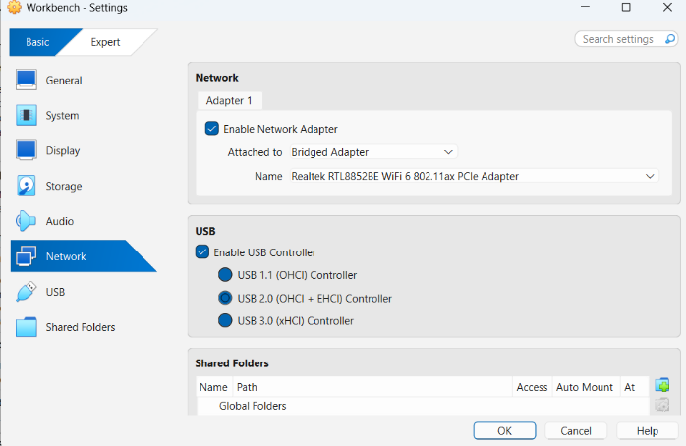
- Select the physical network interface that the host is currently using.
For example:
Wi-Fi
or
Ethernet
- Click OK.
- Start the VM.
The VM will now appear on the same physical network as the host.
13.1 Verify the Configuration
On Linux:
ip addr
On Windows:
ipconfig
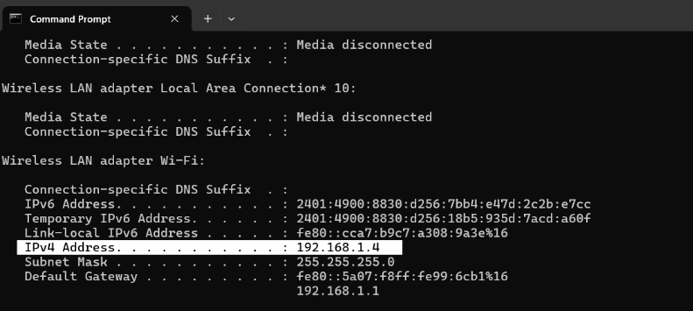
Then test the network gateway:
ping <gateway-ip>
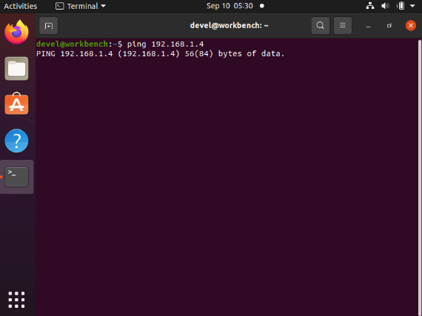
And test Internet connectivity:
ping 8.8.8.8

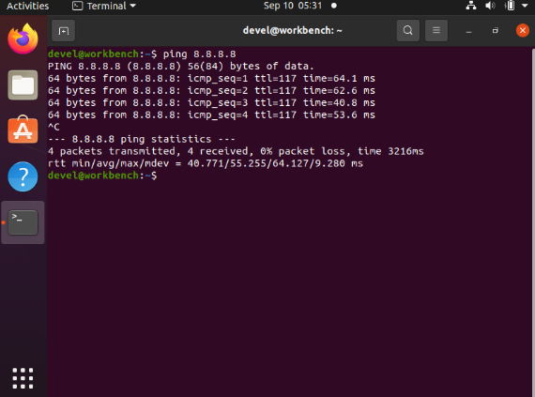
14. Configure Host-Only Adapter in VirtualBox
Host-Only networking requires a Host-Only network to be available.
Step 1 — Open Network Manager
In VirtualBox, open the Network Manager.
This can be accessed by enabling the Expert mode in Virtualbox.
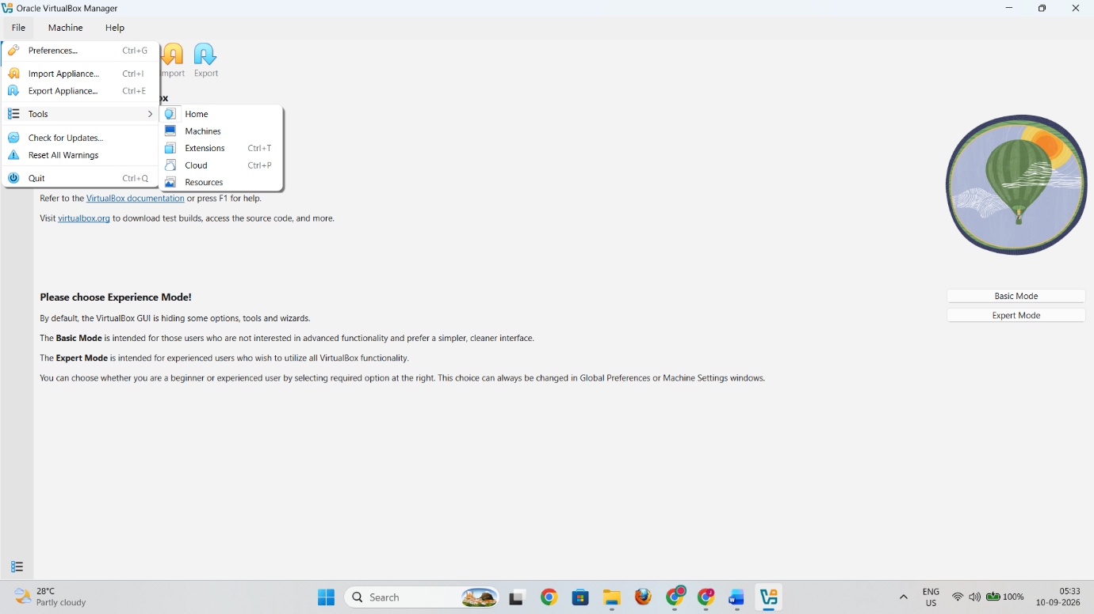Then go to File > Tools > Network.

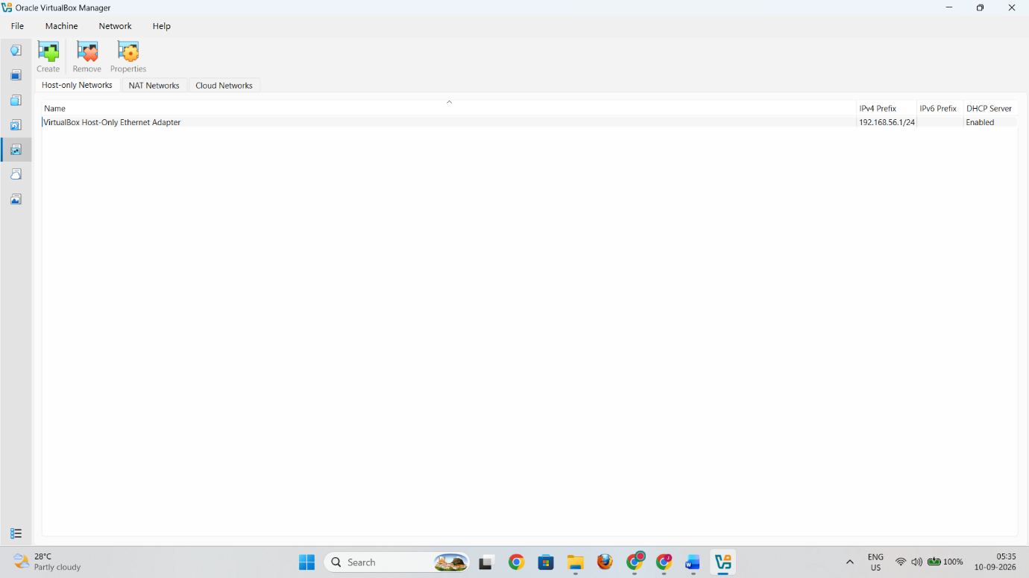Create a Host-Only network if one does not already exist.
It may have an address such as:
192.168.56.1
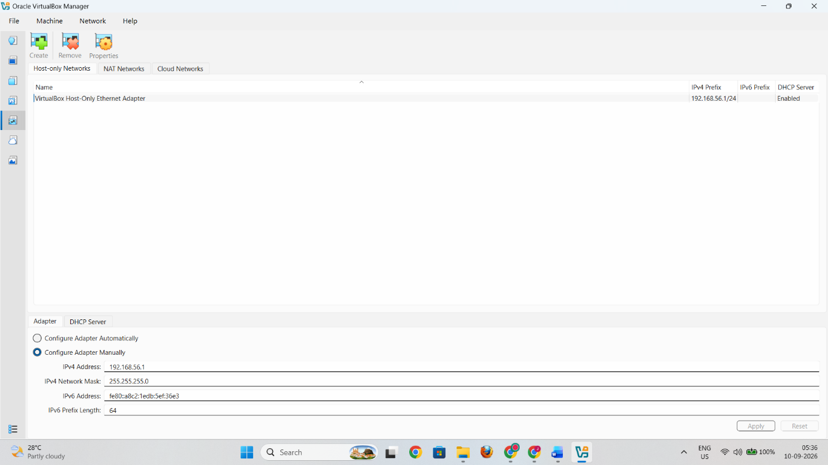
A DHCP server may also be enabled to automatically assign addresses to VMs.
Step 2 — Attach the VM
- Open the VM's Settings.
- Select Network → Adapter 1.
- Enable the adapter.
- Set:
Attached to: Host-only Adapter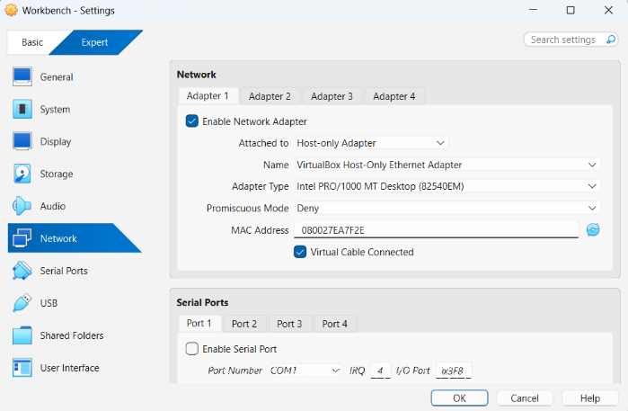
- Select the required Host-Only network.
- Click OK.
- Start the VM.
14.1 Test Host-to-VM Communication
Check the VM's IP address:
ip addr
Suppose it receives:
192.168.56.101
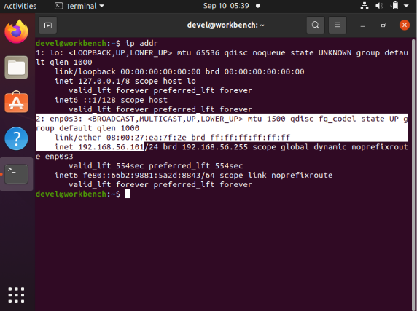
From the host:
ping 192.168.56.101
A successful response confirms that the Host-Only network is functioning.
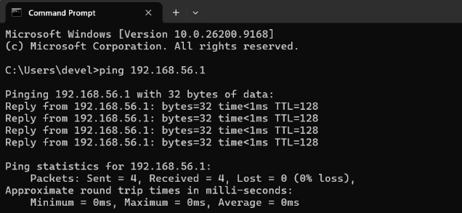
15. Configure Internal Network in VirtualBox
Internal Network is particularly useful when two or more VMs need to communicate privately.
Steps
- Power off the VM.
- Open:
Settings → Network → Adapter 1
- Enable the network adapter.
- Set Attached to:
Internal Network
- Enter a network name, for example:
LabNetwork
- Click OK.
Repeat the same configuration on another VM:
Attached to: Internal Network
Name: LabNetwork
Both VMs are now connected to the same internal virtual network.
18. Troubleshooting
Problem 1: VM has no Internet
Check:
- Network adapter is enabled.
- Correct networking mode is selected.
- Connect at power on is enabled in VMware.
- The host itself has Internet access.
- The guest has received an IP address.
Check using:
ip addr
or:
ipconfig
Problem 2: VM has an IP but websites do not open
Test connectivity to an IP:
ping 8.8.8.8
Then test DNS:
ping google.com
If the first works but the second does not, the problem may involve DNS configuration.

Problem 3: Host cannot ping VM
Check:
- Whether Host-Only or Bridged networking is configured correctly.
- VM firewall settings.
- Whether both devices are on compatible networks.
- The VM's current IP address.
Problem 4: Two VMs cannot communicate
For an Internal Network:
- Both VMs must use the same Internal Network name.
- Both VMs must have compatible IP addresses and subnet masks.
- Firewalls must allow the required traffic.

19. Result
The virtual networking configurations were successfully studied and configured in VMware Workstation and Oracle VirtualBox. NAT, Bridged, Host-Only, and Internal/Private networking concepts were examined, and connectivity was verified using IP configuration and ping commands.

